Assignment 2

Software Design

Student : Tudor Roxana Ioana

Group 30434

Teacher : Bindea Bogdan

2022

Contents

1. Introduction 3

2. Technology used: 4

2.1 Frontend framework 4

2.2 Data storing:MySQL 4

3. Use cases 4

3.1 A few examples: 4

3.2 Design a functionality: 5

4. Architecture 9

5. Testing 10

6. Bibliography 10

# Introduction

This assignment consist on building our own version of Stack Overflow.

Stack Overflow is a question and answer website for professional and enthusiast programmers. It is the flagship site of the Stack Exchange Network, created in 2008 by Jeff Atwood and Joel Spolsky. It features questions and answers on a wide range of topics in computer programming. Both the questions and answers can be voted (liked or disliked) and based on the votes from their questions and answers the user are assigned a score. The display of the answers it is performed according to their score.

The implementation of the backend part of the project is composed of the basic CRUD operation performed on a database that contains the questions, answers, users and votes.

We can perform a insertion on question/answers or users, update their information or delete them from the database. A questions has tags and if they don't exist in the database they will be created.

The application will contain the user parameter which is able to post question or answers, edit his post, vote posts of other people and search for question according to a filter.

# Technology used:

## Frontend framework

The framework used is Angular, which combines HTML, SCSS and Javascript. The version of Angular used is 13. This framework works on components and is usually used for framework for building single page client applications

## Data storing:MySQL

MySQL application is used for data storing

# Use cases

## A few examples:

**Use case:** Add a question

**Primary actor:** User

**Main success scenario:** The user must be logged in before he/she is able to add his new question. In order to post the question he must write the title, the content and a few tags. After inserting this information the user presses the button and the question will be posted on the website.

**Use case:** Add a question

**Primary actor:** User

**Main success scenario:** The user adds his answer to a particular question. Under each question there will be a button called “Answer this”. After clicking on it he is able to write his answer to the question. If he thinks that the information is enough he presses the post button. Now his answer is displayed on the website.

**Use case:** Edit a question

**Primary actor:** User

**Main success scenario:** The user can edit or delete his question when he thinks that his response has given a false information or is no longer valid.

**Use case:** Answer a questions

**Primary actor:** User

**Main success scenario:** The user adds his answer to a particular question. Under each question there will be a button called “Answer”, but only if you are logged in. After clicking on it he is able to write his answer to the question. If he thinks that the information is enough he presses the save button. Now his answer is displayed on the website.

## Design a functionality:

Home page for the guest users:

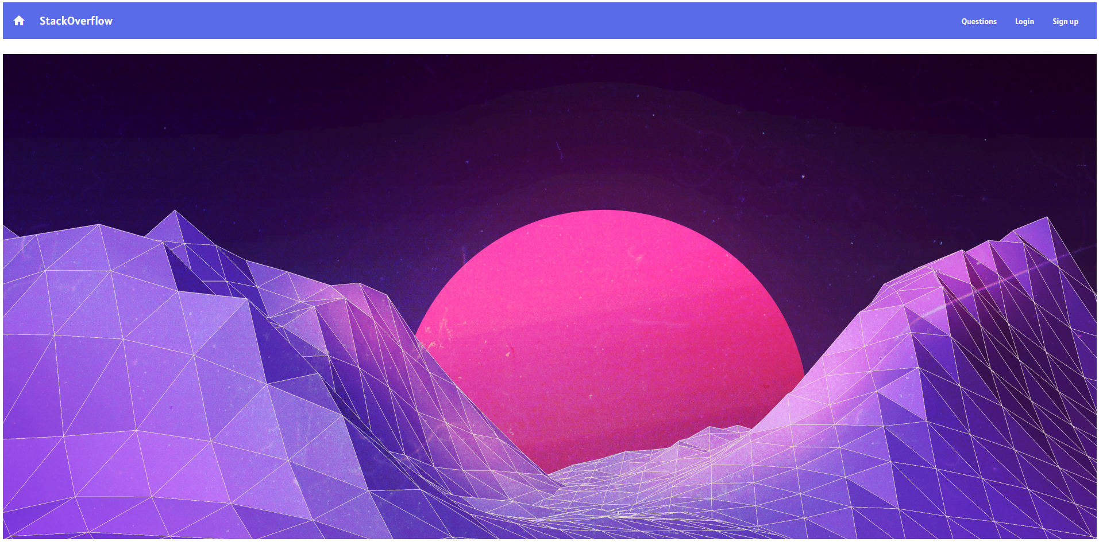

Listing the questions:

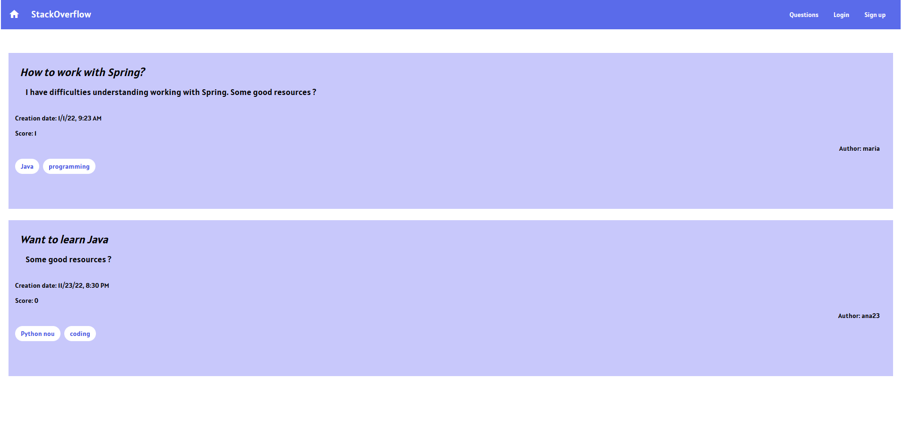

How the homepage is displayed after logging in :

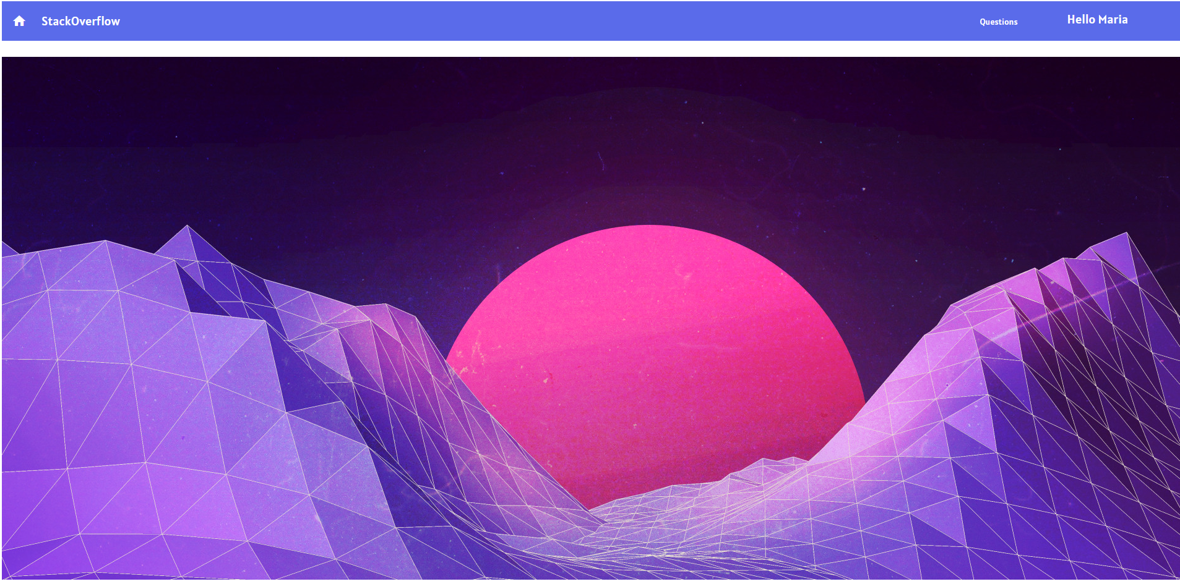

Login page:

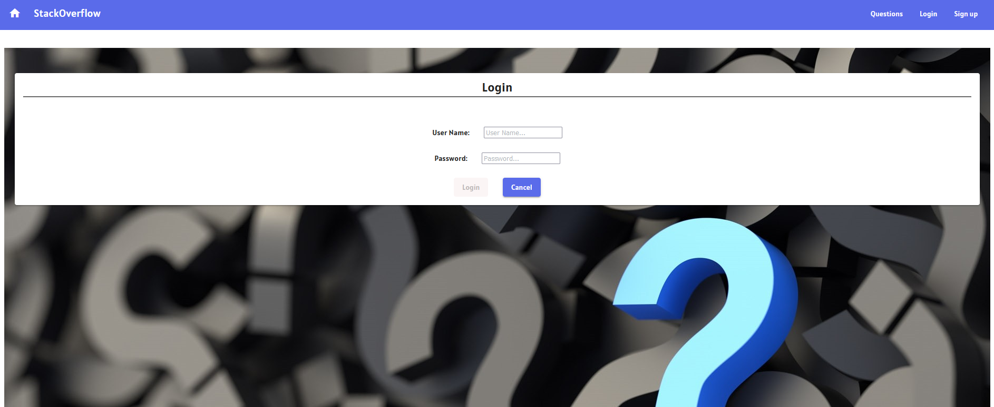

Register page:

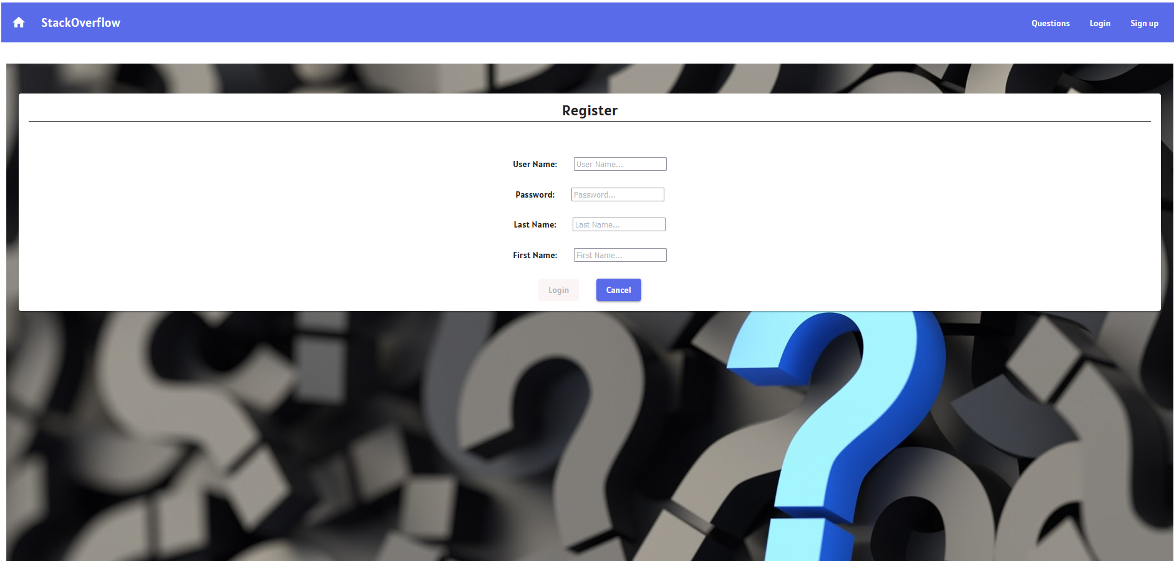

User profile:

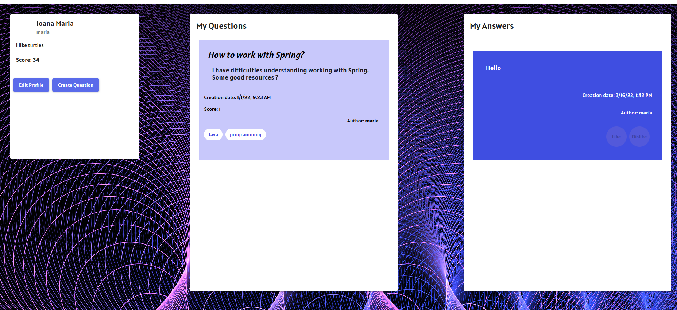

The user can click on Create Question button in order to ask a new question and a form will be displayed:

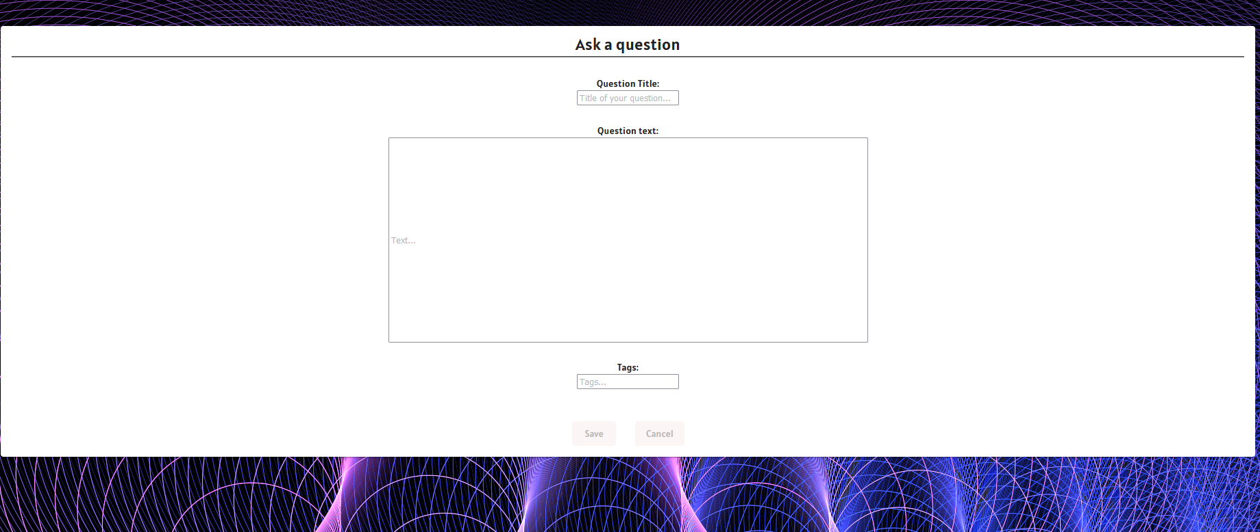

The user can click on his question, and he will be able to edit or delete it or even answer it. But the like and dislike button are disabled for him (he isn’t able to vote his own content).

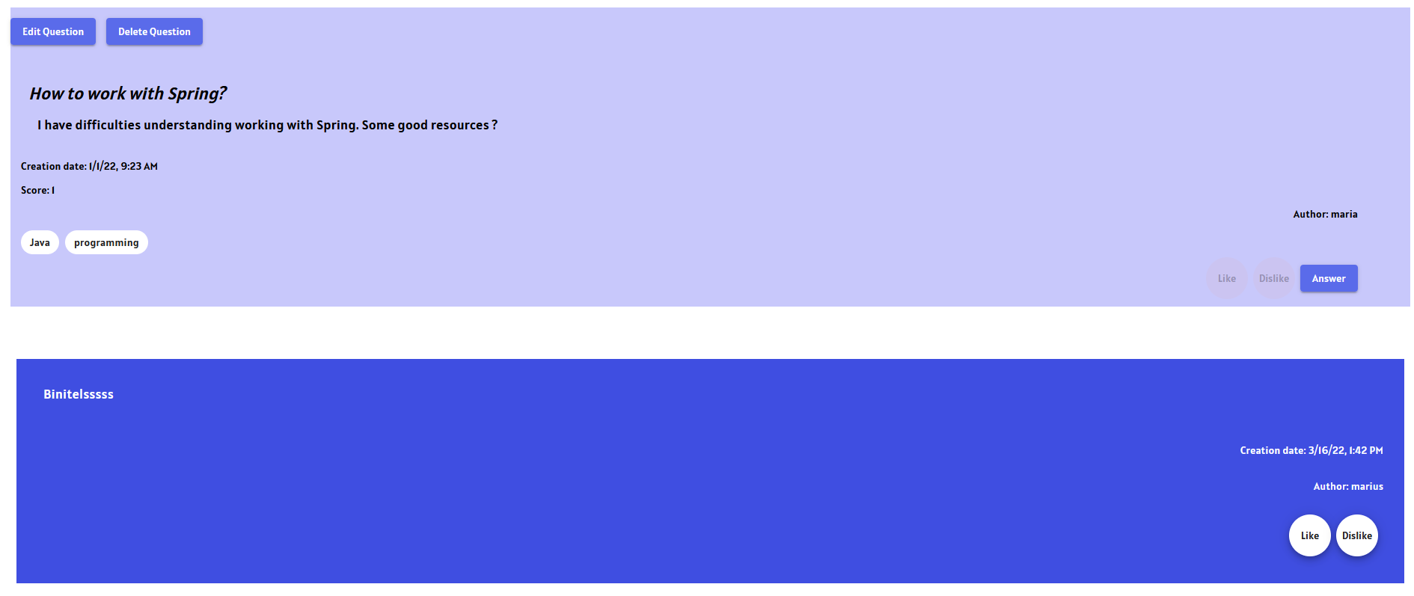

For example, clicking on Edit Question, we will be taken to a from, where he is able to modify his input:

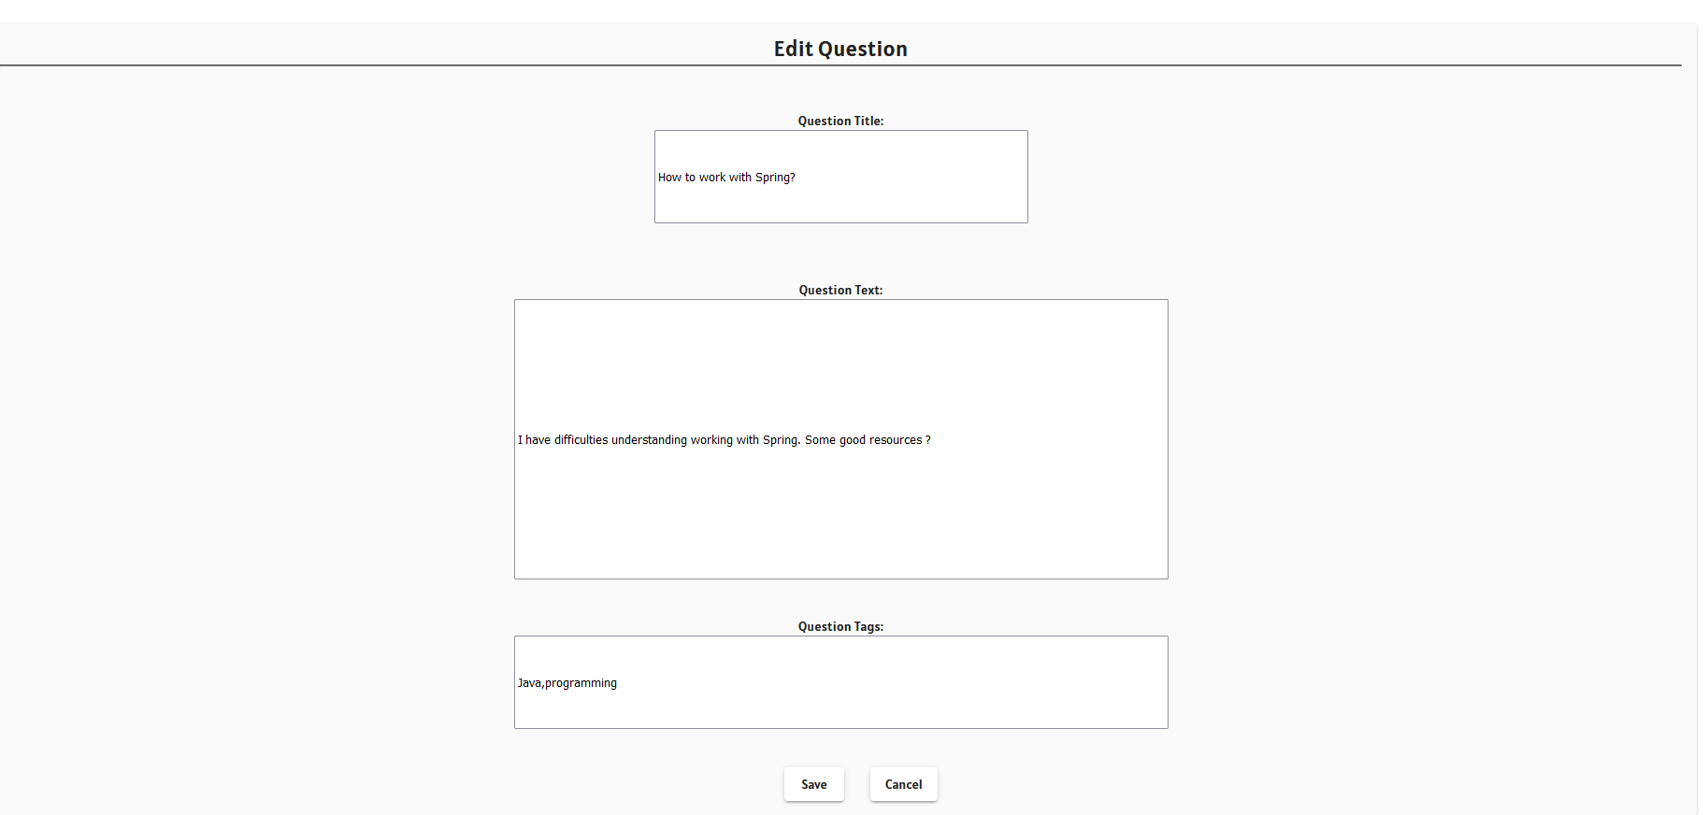

# Architecture

This architecture is one of the most used architectures in software engineering because it is the best approach to divide the work on specific modules.

The Modular design decouples the application into blocks of functionality and makes it easier to maintain and test.

A interpretation of the High level project architecture was used. In the High level project architecture we have the following layers:

* Presentation layer: they represent the pages written in HTML and stylized with SCSS
* Abstraction layer: which handles the communication between the webpage and the core layer
* Core layer: Contain the logic of the application (data manipulation, etc.)

Knowing that in angular you work with component I have decided to divide my work in three main directories.

First directory is called models and they contain the interfaces of the objects that I’ve used for representing the questions, answers, user and tags.

Second directory is called pages, and this represents the presentation layer, here I have all the pages or components used for building the interface.

Third directory is called service and this contain the services used for implementing the main functionalities of the project.

Components are divided into smart (containers) and dumb (components). Smart components are the ones which listen for their children’s events, communicates with the application core layer.

(example question with “question_thumbnail” or “question_details”)

# Testing

I have done some test manually, going through each page and testing if the routing is done properly.

I have verified if the buttons do their job, and route to another page or display the new data that I want.

A few tests defined:

it("should question list bigger than 0", () =>

{

// @ts-ignore

expect(component.questions?.length > 0)

})

it("question tags bigger than 0", () =>

{

// @ts-ignore

for ( let x of component.questions)

{

// @ts-ignore

expect(x.tags.length > 0)

}

})

it("question must have a author", () =>

{

// @ts-ignore

for ( let x of component.questions)

{

// @ts-ignore

expect(x.author != null)

}

})

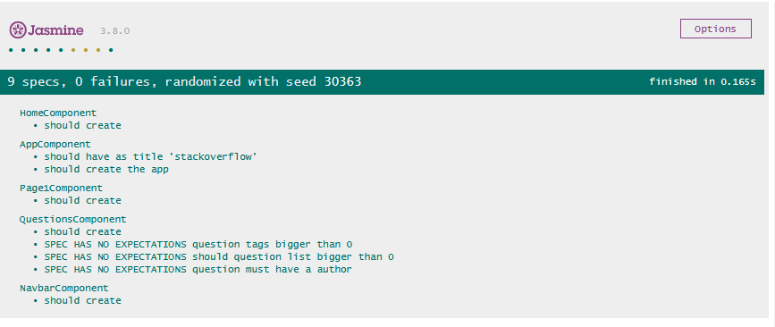

# Bibliography

<https://www.oreilly.com/library/view/software-architecture-patterns/9781491971437/ch01.html>

<https://medium.com/nonstopio/angular-architecture-pattern-bc69f9c3372c>

<https://app.pluralsight.com/course-player?clipId=aede2ad2-17b4-4ca9-8969-6153d659b049>

https://angular.io/guide/testing